NAME: MALOTH ADITYA
ROLL NO.: 120CS0124

Q.1

Client Code:
// Client side implementation of UDP client-server model
#include <stdlib.h>
#include <unistd.h>
#include <stdio.h>
#include <sys/types.h>
#include <sys/socket.h>
#include <arpa/inet.h>
#include <netinet/in.h>

#define SA struct sockaddr

int main(){
int sid;
char c='Y';
struct sockaddr_in server_address;
int ser_len;
server_address.sin_family = AF_INET;
server_address.sin_addr.s_addr = inet_addr("127.0.0.1");
server_address.sin_port = 6969;
ser_len = sizeof(server_address);
printf("Character sent: %c\nSeeking a signal from server\n\n",c);
sid=socket(AF_INET,SOCK_DGRAM,0);
sendto(sid,&c,1,0,(SA *)&server_address,ser_len);
recvfrom(sid,&c,1,0,(SA *)&server_address,&ser_len);
printf("Character received from server: %c\n\n",c);
close(sid);
return 0;
}

Server Code:
// Server side implementation of UDP client-server model
#include <stdlib.h>
#include <unistd.h>
#include <stdio.h>
#include <sys/types.h>
#include <sys/socket.h>
#include <arpa/inet.h>
#include <netinet/in.h>

#define SA struct sockaddr

int main(){
int sockfd;
char c;
struct sockaddr_in servaddr, cliaddr;

servaddr.sin_family = AF_INET;
servaddr.sin_addr.s_addr = inet_addr("127.0.0.1");
servaddr.sin_port = 6969;
int ser_len = sizeof(servaddr);
int cli_len = sizeof(cliaddr);
sockfd = socket(AF_INET,SOCK_DGRAM,0);
bind(sockfd,(SA *)&servaddr,ser_len);

while(1){
printf("----------------------------\n");
printf("Ready to receive datagram :)\n");
recvfrom(sockfd,&c,1,0,(SA *)&cliaddr,&cli_len);
printf("Received %c\n",c);
c='X';
sendto(sockfd,&c,1,0,(SA *)&cliaddr,cli_len);
printf("____________________________\n\n");
}
close(sockfd);
return 0;
}

Output:
Client Output:
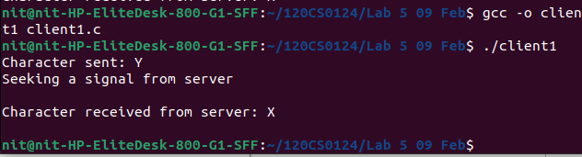
Server Output:
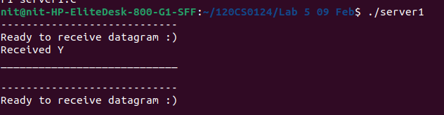

Q.2

Client Code:
// Client side implementation of UDP client-server model
#include <stdlib.h>
#include <unistd.h>
#include <stdio.h>
#include <sys/types.h>
#include <sys/socket.h>
#include <arpa/inet.h>
#include <netinet/in.h>

#define SA struct sockaddr

int main(){
int sid,num1,num2,res;
printf("Enter num1: ");
scanf("%d",&num1);
printf("Enter num2: ");
scanf("%d",&num2);
struct sockaddr_in server_address;
int ser_len;
server_address.sin_family = AF_INET;
server_address.sin_addr.s_addr = inet_addr("127.0.0.1");
server_address.sin_port = 6969;
ser_len = sizeof(server_address);
printf("Seeking a signal from server\n\n");
sid=socket(AF_INET,SOCK_DGRAM,0);
sendto(sid,&num1,sizeof(num1),0,(SA *)&server_address,ser_len);
sendto(sid,&num2,sizeof(num2),0,(SA *)&server_address,ser_len);
recvfrom(sid,&res,sizeof(res),0,(SA *)&server_address,&ser_len);
printf("Sum received from server: %d\n",res);
close(sid);
return 0;
}

Server Code:
// Server side implementation of UDP client-server model
#include <stdlib.h>
#include <unistd.h>
#include <stdio.h>
#include <sys/types.h>
#include <sys/socket.h>
#include <arpa/inet.h>
#include <netinet/in.h>

#define SA struct sockaddr

int main(){
int sockfd,res,num;
//const char hello = "Hello from server";
struct sockaddr_in servaddr, cliaddr;

servaddr.sin_family = AF_INET;
servaddr.sin_addr.s_addr = inet_addr("127.0.0.1");
servaddr.sin_port = 6969;
int ser_len = sizeof(servaddr);
int cli_len = sizeof(cliaddr);
sockfd = socket(AF_INET,SOCK_DGRAM,0);
bind(sockfd,(SA *)&servaddr,ser_len);

while(1){
printf("____________________________\n");
printf("Ready to receive datagram :)\n");
recvfrom(sockfd,&res,sizeof(res),0,(SA *)&cliaddr,&cli_len);
recvfrom(sockfd,&num,sizeof(num),0,(SA *)&cliaddr,&cli_len);
printf("Received num1: %d\tnum2: %d\n",res,num);
res=res+num;
sendto(sockfd,&res,sizeof(res),0,(SA *)&cliaddr,cli_len);
printf("----------------------------\n\n");
}
close(sockfd);
return 0;
}

Output:
Client Output:
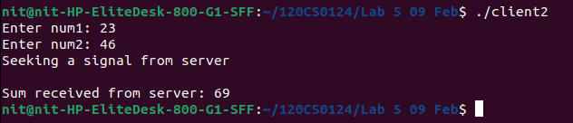

Server Output:

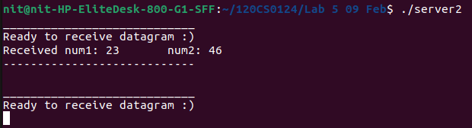
Q.3

Client Code in UDP:
// Client side implementation of UDP client-server model
#include <stdlib.h>
#include <unistd.h>
#include <stdio.h>
#include <sys/types.h>
#include <sys/socket.h>
#include <arpa/inet.h>
#include <netinet/in.h>

#define SA struct sockaddr

void prime(int num){
if(num) printf("prime number\n");
else printf("not a prime number\n");
}

int main(){
int sid,num1,num2,res;
printf("Enter num1: ");
scanf("%d",&num1);
printf("Enter num2: ");
scanf("%d",&num2);
struct sockaddr_in server_address;
int ser_len;
server_address.sin_family = AF_INET;
server_address.sin_addr.s_addr = inet_addr("127.0.0.1");
server_address.sin_port = 6969;
ser_len = sizeof(server_address);
printf("\n\nSeeking a signal from server\n");
sid=socket(AF_INET,SOCK_DGRAM,0);
sendto(sid,&num1,sizeof(num1),0,(SA *)&server_address,ser_len);
sendto(sid,&num2,sizeof(num2),0,(SA *)&server_address,ser_len);
int diff,prod,quo;
recvfrom(sid,&diff,4,0,(SA *)&server_address,&ser_len);
recvfrom(sid,&prod,4,0,(SA *)&server_address,&ser_len);
recvfrom(sid,&quo,4,0,(SA *)&server_address,&ser_len);
//for(int i=0;i<3;i++) rans[i]=ntohl(ans[i]);
printf("Heard something from server\n");
printf("\nDifference: %d\nProduct: %d\nQuotient: %d\n",diff,prod,quo);
if(quo==-1) printf("Since num2 is 0, couldn't perform division\n");
printf("-----Checking if a number is prime-----\n");
printf("%d: ",num1);
recvfrom(sid,&num1,4,0,(SA *)&server_address,&ser_len);
prime(num1);
printf("%d: ",num2);
recvfrom(sid,&num2,4,0,(SA *)&server_address,&ser_len);
prime(num2);
close(sid);
return 0;
}

Server Code in UDP:
// Server side implementation of UDP client-server model
#include <stdlib.h>
#include <unistd.h>
#include <stdio.h>
//#include <string.h>
#include <sys/types.h>
#include <sys/socket.h>
#include <arpa/inet.h>
#include <netinet/in.h>

#define SA struct sockaddr

#define PORT 6969
#define MAXLINE 1024

int prime(int num){
for(int i=2;i*i<=num;i++){
if(num%i==0){
printf("Not a prime number\n");
return 0;
}
}
printf("Prime number\n");
return 1;
}

int main(){
int sockfd,res,num;
struct sockaddr_in servaddr, cliaddr;

servaddr.sin_family = AF_INET;
servaddr.sin_addr.s_addr = inet_addr("127.0.0.1");
servaddr.sin_port = 6969;
int ser_len = sizeof(servaddr);
int cli_len = sizeof(cliaddr);
sockfd = socket(AF_INET,SOCK_DGRAM,0);
bind(sockfd,(SA *)&servaddr,ser_len);
int diff,prod,quo;
while(1){
printf("____________________________\n");
printf("Ready to receive datagram :)\n");
recvfrom(sockfd,&res,sizeof(res),0,(SA *)&cliaddr,&cli_len);
recvfrom(sockfd,&num,sizeof(num),0,(SA *)&cliaddr,&cli_len);
printf("Received num1: %d\tnum2: %d\n",res,num);
diff = res-num;
prod = res*num;
//for(int i=0;i<3;i++) sans[i]=htonl(ans[i]);
if(num==0) quo=-1;
else quo = res/num;
printf("\nDifference: %d\nProduct: %d\nQuotient: %d\n",diff,prod,quo);
printf("%d: ",res);
res=prime(res);
printf("%d: ",num);
num=prime(num);
sendto(sockfd,&diff,4,0,(SA *)&cliaddr,cli_len);
sendto(sockfd,&prod,4,0,(SA *)&cliaddr,cli_len);
sendto(sockfd,&quo,4,0,(SA *)&cliaddr,cli_len);
sendto(sockfd,&res,4,0,(SA *)&cliaddr,cli_len);
sendto(sockfd,&num,4,0,(SA *)&cliaddr,cli_len);
printf("----------------------------\n\n");
}
close(sockfd);
return 0;
}

Output:
Client Output:
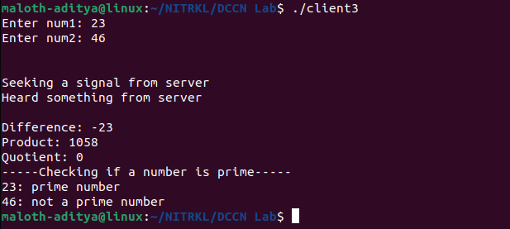
Server Output:

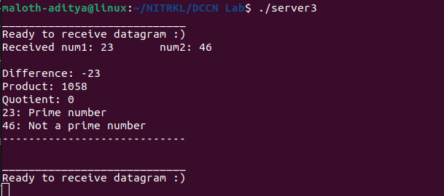

Q.3

Client Code in TCP:
// Client side implementation of TCP client-server model
#include <sys/types.h>
#include <sys/socket.h>
#include <netinet/in.h>
#include <stdio.h>
#include <unistd.h>
#include <stdlib.h>
#include <arpa/inet.h>

void prime(int num){
if(num) printf("prime number\n");
else printf("not a prime number\n");
}

int main(){
int sid,num1,num2;
printf("Enter num1: ");
scanf("%d",&num1);
printf("Enter num2: ");
scanf("%d",&num2);
struct sockaddr_in server_address;
int server_addlen;
server_address.sin_family=AF_INET;
server_address.sin_addr.s_addr=inet_addr("127.0.0.1");
server_address.sin_port=5080;
server_addlen=sizeof(server_address);
sid=socket(AF_INET,SOCK_STREAM,0);
connect(sid,(struct sockaddr *)&server_address,server_addlen);
printf("Sending data to server\n");
write(sid,&num1,sizeof(int));
write(sid,&num2,sizeof(int));

int diff,prod,quo,ans[3];
read(sid,&diff,sizeof(int));
read(sid,&prod,sizeof(int));
read(sid,&quo,sizeof(int));
printf("\nDifference: %d\nProduct: %d\nQuotient: %d\n",diff,prod,quo);
if(quo==-1) printf("Since num2 is 0, couldn't perform division\n");
printf("-----Checking if a number is prime-----\n");
printf("%d: ",num1);
read(sid,&num1,sizeof(int));
prime(num1);
printf("%d: ",num2);
read(sid,&num2,sizeof(int));
prime(num2);
close(sid);
return(0);
}

Server Code in TCP:
// Server side implementation of TCP client-server model
#include <sys/types.h>
#include <sys/socket.h>
#include <netinet/in.h>
#include <stdio.h>
#include <unistd.h>
#include <stdlib.h>
#include <arpa/inet.h>

int prime(int num){
for(int i=2;i*i<=num;i++){
if(num%i==0){
printf("Not a prime number\n");
return 0;
}
}
printf("Prime number\n");
return 1;
}

int main(){
int serid,sessid;
int res,num;
struct sockaddr_in server_address,client_address;
int server_addlen,client_addlen;
server_address.sin_family=AF_INET;
server_address.sin_addr.s_addr=inet_addr("127.0.0.1");
server_address.sin_port=5080;
server_addlen=sizeof(server_address);
client_addlen=sizeof(client_addlen);
serid=socket(AF_INET,SOCK_STREAM,0);
bind(serid,(struct sockaddr*)&server_address,server_addlen);
listen(serid,10);
while(1){
printf("________________________________\n");
printf("Server is ready to accept ......\n");
sessid=accept(serid,(struct sockaddr *)&client_address,&client_addlen);
read(sessid,&res,sizeof(int));
read(sessid,&num,sizeof(int));
printf("Received num1: %d\tnum2: %d\n",res,num);
int prod,diff,quo;
diff = res-num;
prod = res*num;
if(num==0) quo=-1;
else quo = res/num;
printf("\nDifference: %d\nProduct: %d\nQuotient: %d\n",diff,prod,quo);
printf("%d: ",res);
res=prime(res);
printf("%d: ",num);
num=prime(num);
write(sessid,&diff,sizeof(int));
write(sessid,&prod,sizeof(int));
write(sessid,&quo,sizeof(int));
write(sessid,&res,sizeof(int));
write(sessid,&num,sizeof(int));
printf("----------------------------------\n\n");
close(sessid);
}
return(0);
}

Output:
Client Output:
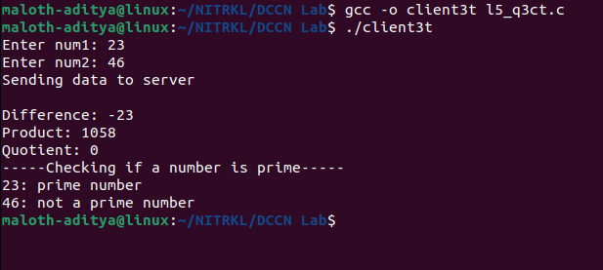

Server Output:
